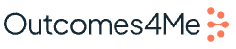
Data room (password: O4M2025)

Opportunity
- Raising $10M total, $6m left on this round for 13% equity
- $40M pre-money valuation
- Looking for investors with fintech & employer/health system relationships
- Doing a discounted round because the last one was in the height of the hype cycle, overpriced (this is according to Sierra Ventures – Vignesh led the seed and is on the board)
- NBC Is a strategic investor – traded media or equity
- Must close by 3/31 - current board interested to do the full $6M but open to bringing on a strategic who can add value through other channels
- Founded by Maya Said – strong background in pharma and oncology
  - Was Senior Vice President, Global Head Oncology Policy & Market Access
  - Board of Directors at Pieris Pharmaceuticals
Company Overview
- Provides a free app to cancer patients with tailored insights based on NCCN guidelines
- Gather cancer treatment recommendations typically meant for oncologists and use AI to translate that information so patients can understand it
- First cancer app to integrate with the NCCN Clinical Practice Guidelines from the not-for-profit alliance of 33 leading cancer centers
- The longitudinal data they collect on patients becomes extremely valuable to providers and pharma companies
  - For providers à patients come into the office equipped with extremely personalized data, helping them do their jobs better (testimonials here)
  - For pharma à data becomes extremely valuable for targeted marketing
- App video here
Traction / Biz Model
- At $7.2M run rate as of Q4 2024
- Their two revenue streams are precision marketing and anonymized patient datasets
- Growing interest from healthcare systems – wants to consider expanding to employers and systems
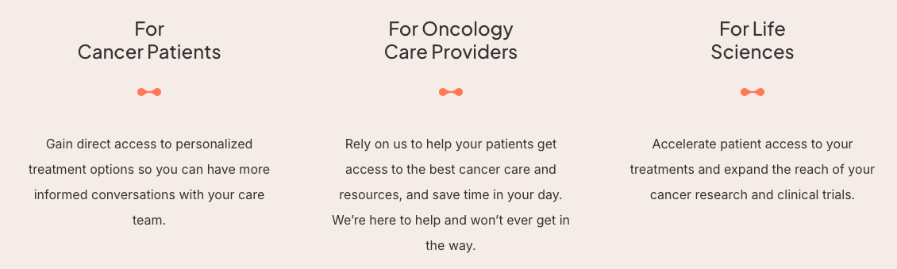
Workplan
- Follow up after transform with meetings –
  - Healthcare advisors Made introductions to Ken Goulet, Jimmy Lee, Ron Fontanetta, Molly Loftus, Jane Jensen, Mary Tavarozzi
  - Eric and Lesley – Sequoia Done – feedback from Lesley below:
    - I had a great conversation with Maya. I appreciated her ability to clearly articulate the value of her company and be passionate and humble in the areas that she has deep knowledge and where she needs help learning more. She asked some really great questions about the employer space and healthcare delivery, which showed me she's able to grow and learn and pivot.
    - From a product standpoint, outcomes4me approach to collaborate with the pharmaceutical space initially is very smart. I like their approach can also partner with other cancer solutions such as a GRail, color health or even rightway for care nav or PBM.
    - Having had experienced breast cancer personally and seeing the gaps that a company like outcomes4me could close, it does seem like there is a real need for it.
    - The challenges will always be how to price it. She and I talked about the ROI And some creative ways to prove ROI and what employers generally need to get by in to purchase something like this. And that is especially challenging in this economic climate.
    - While we are seeing some point solutions on the table these days to potentially sunset if not adding a ton of measurable value, addressing cancer is one that still seems to peek their attention.
  - Met with Henri and Caribou – need feedback
  - Joanna, carl as founder references Maya met with Joanna
- Meet more exec & tech team – scheduled for Friday 3/21
- Meet Merstal done – full notes in Affinity
- Backchannel with existing investors
  - Sierra Ventures– RS met with Vignesh 2/25 who led the seed round (full notes in Affinity)
    - Extremely strong feedback from Vignesh on where the business is today – he basically said at this price it’s kind of a “no brainer” compared to where the business was when he invested/last couple of years
  - Labcorp – RS met with Isabelle on 2/26 (full notes in Affinity)
    - Strong feedback on Maya, Labcorp is also a customer of theirs for precision marketing for genetic tests
  - Lapcorp – Meeting with Megann on 3/11 (led the deal at Lapcorp)
- Meeting with customers
  - Rebecca A. Previs, MD, MS - Director of Oncology Medical Affairs at Lapcorp
    - Lapcorp used Outcomes4Me on a project that fulfilled both education and research objectives for metastatic breast cancer. It was a one-time project funded through a special CSO budget allocation but they are actively in the process of proposing another project focused on tumor agnostic biomarker education program. Becca said there are no other tech competitors in the space, and the main alternatives are advocacy groups (Coleman, OOCRA) which she noted as slower/less efficient
    - "Patient education is really lacking. [Outcomes4Me] is Olympic level. Everyone else is kind of in the I don't know, major, minor leagues."
    - Also no other platform that takes clinical guidelines (NCCN) into account – she really cares about this because she is an oncologist
    - She described Maya as visionary but sometimes challenging to align with because she has “such a big vision that doesn’t always line up with budget constraints”
    - She ended up working with Janessa and Ashima – praised them both as “fantastic” implementation leads
  - Bill Ablaschai - Director, Patient Marketing, Elacestrant Full notes in Affinity
  - Dr. Sunil Verma - Head of oncology franchise at AstraZeneca Full notes in Affinity
- Get blurbs for our network blurb included at end of this doc
  - Molly Loftus notes in affinity
  - Ron Fontanetta notes in affinity
  - Sequoia sent to Lesley and Eric
  - Mt. Sinai sent, intro made
  - CU Anschutz sent, intro made
  - UPMC sent – connecting with Curtis on it
  - Ping to Cigna –
  - JP and Larry Leisure – Mend AI
- Invite to Transform done

Follow-Up Questions
- Why aren’t there more positive reviews on the app store? (GG)
- Who is building out consumer GTM strategy / acquisition (CH)
- Round dynamics Have a $10M Series A extension open and have $6M left – not on a note, purchasing Series A + shares 100% penny warrant Series A preferred, immediately exercisable
  - North Pond Ventures led their Series A ext (this round)
  - Initial Series A
- What are the milestones to get to Series B?
- Cap table In data room
- More details on CAC:LTV
- What is your pathway to demonstrating better outcomes for patient
- What is your pathway to demonstrating reduced pharma spend for payers?
- What is most of R&D spend going to
- Are there other key members of the team we should meet?
- What are the key hires you're looking to make before the B?
- Also can you walk us through the financial model and what is driving the large fluctuations quarter over quarter?
- Can you introduce us to your lead investor? Intros made to Merstal and Northpond
- How do you think about total market size? Pharma companies spend $20B annually on marketing to reach the right patients
- Backchannels with customers Maya connected us to two customers - Dr. Sunil Verma, SVP Global Head Oncology Franchise at AstraZeneca and Bill Ablaschai - Director, Patient Marketing, Elacestrant
What do we need to believe
- For ability for us to drive value, we need to believe there is a GTM strategy through employers at health systems at some point. Maya believes her next step in accelerating revenue would be through self-insured employers
- Maya can build a D2C business despite not having experience doing it before

Product Overview
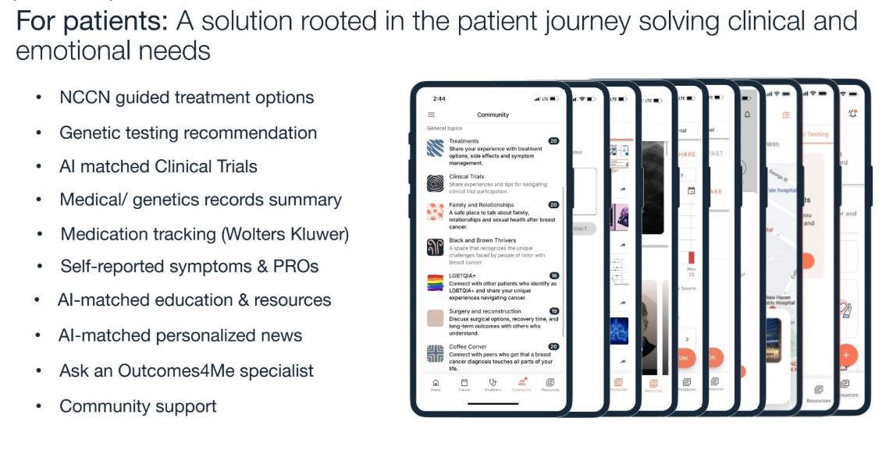
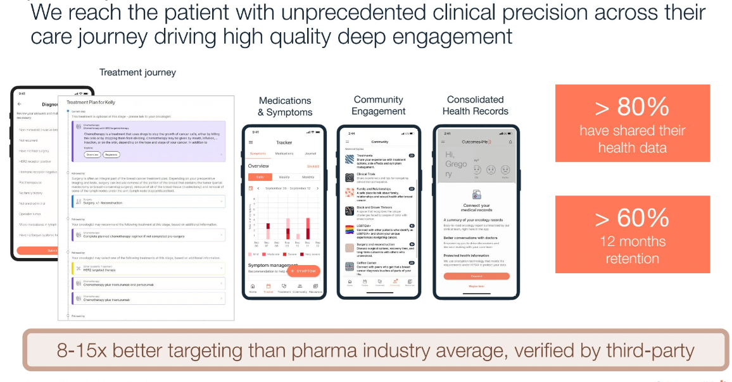
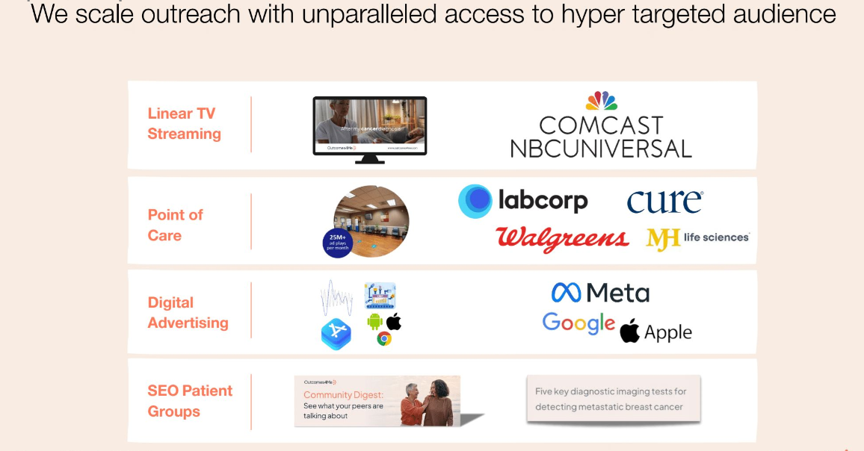

Market Overview
- “More than 50% of drugs now in development are for cancer therapy.” Jeff Patton, MD, a board-certified hematologist/oncologist and CEO of OneOncology in Nashville, told Oncology News Central.
- In January and February 2021, cancer prescription drugs spent $104mm across TV (72%), print (24%), and digital (4%). Overall, this is up 57% over January and February of 2020.
Network Blurbs
- For providers:
Named a 2024 Fast Company World Changing Idea, Outcomes4Me is an award winning Boston-based healthtech company unlocking the future of Oncology by connecting and transforming health and consumer data into a meaningful actionable experience for patients to achieve the best outcomes. Through its patented technology and AI-driven patient empowerment platform, the company has built the largest network of cancer patients with over 250,000 patients using its platform in every US state covering over 2,000 different health systems and providers. By bridging the gap between patients, innovative therapies, and evidence-based guidelines, Outcomes4Me aims to improve treatment outcomes and enhance the overall healthcare experience.

While Outcomes4Me so far has been focused on the patient experience and partnerships with life sciences companies, they have had some partnerships with providers around specific use cases including with Vanderbilt Cancer Center on survivorship care navigation and coordination, Mass General Hospital on clinical trial matching and recruitment, and Johns Hopkins on PROs and symptom management. Their goal is to empower patients by connecting the patient journey around the point of care to help patients together with their provider achieve the best outcomes incorporating the latest science as well as individual preferences. As a result, they are very interested to continue building on the provider use case and expanding their network of partnerships with providers. You can find here a brief into the company and platform.

Please let us know if you would like to connect with the Founder and CEO, Dr. Maya Said.

- For payers:
Named a 2024 Fast Company World Changing Idea, Outcomes4Me is an award winning Boston-based healthtech company unlocking the future of Oncology by connecting and transforming health and consumer data into a meaningful actionable experience for patients to achieve the best outcomes. Through its patented technology and AI-driven patient empowerment platform, the company has built the largest network of cancer patients with over 250,000 patients using its platform in every US state covering over 2,000 different health systems and providers. By bridging the gap between patients, innovative therapies, and evidence-based guidelines, Outcomes4Me aims to improve treatment outcomes and enhance the overall healthcare experience.

While Outcomes4Me so far has been focused on the patient experience and partnerships with life sciences companies, the platform recently reached a level of scale that makes it relevant to payers. The company’s platform enables the management of the cost of cancer drugs by ensuring effective and efficient dissemination of the right biomarker tests and treatments to the right patients at the right time, coupled with patient navigation to ensure every patient gets the most out of every treatment they receive – ultimately improving cancer outcomes while reducing costs. You can find here a brief overview of the company platform.

Please let us know if you would like to connect with the Founder and CEO, Dr. Maya Said.

- For employers:
Named a 2024 Fast Company World Changing Idea, Outcomes4Me is an award winning Boston-based healthtech company unlocking the future of Oncology by connecting and transforming health and consumer data into a meaningful actionable experience for patients to achieve the best outcomes. Through its patented technology and AI-driven patient empowerment platform, the company has built the largest network of cancer patients with over 250,000 patients using its platform in every US state covering over 2,000 different health systems and providers. By bridging the gap between patients, innovative therapies, and evidence-based guidelines, Outcomes4Me aims to improve treatment outcomes and enhance the overall healthcare experience.

While Outcomes4Me so far has been focused on the patient experience and partnerships with life sciences companies, the platform recently reached a level of scale that makes it relevant to employers. The company’s platform addresses the clinical and non-clinical needs of cancer patients, effectively acting as a second opinion as well as providing resources to help patients get the best treatment, manage the cost of care, but also have access to resources that are not readily available across the health system and that helps them achieve their new normal. They are very interested to discuss potential partnerships with employers as they have been recently approached by a couple HR partners within large employers around specific use cases. You can find here a brief overview of the company platform.

Please let us know if you would like to connect with the Founder and CEO, Dr. Maya Said.

